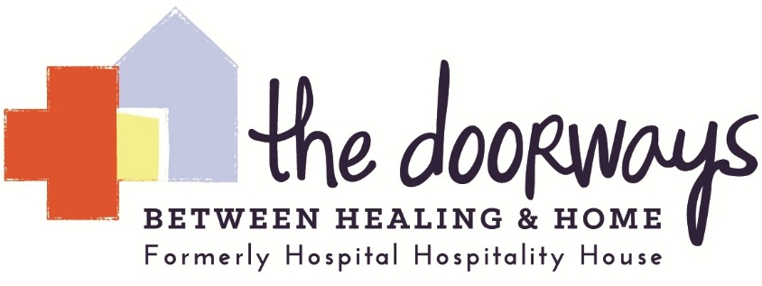

Privacy Policy
Your privacy is important to us. To better protect your privacy we provide this notice explaining our online information practices. Our privacy policy is simple: we collect no information about you unless you choose to provide that information to us. In addition, we do not give, share, sell, or transfer any personal information about you to any third parties. To prevent unauthorized access, maintain accuracy, and ensure the correct use of information, we have put in place appropriate physical, electronic, and managerial procedures to safeguard and secure any information that we collect. If you have questions about our privacy practices, you can contact us at the postal or email address posted on this site.

